# **DEVELOP AN APPLICATION THAT USES LAYOUT MANAGERS AND EVENT LISTENERS**

**EX. NO.** : 02

**DATE:** 30-03- 2022

# **AIM**

To develop a Simple Android Application that uses GUI components, Font and Colors.

# **PROCEDURE**

**Step 1:** Creating a New project:

Open Android Studio and then click on File -> New -> New project. Then type the Application name as “exno2″ and click Next.

**Step 2:** Then select the Minimum SDK as shown below and click Next. Then select the Empty Activity and click Next.

**Step 3:** Finally click Finish.

Note:

It will take some time to build and load the project.

**Step 4:** Designing layout for the Android Application:

Click on app -> res -> layout -> activity_main.xml.

Thus Second Activity For the application is created.

**Step 5:** Java Coding for the Android Application:

Click on app -> java -> com.example.exno2-> MainActivity.

**Step 6:** Run the Application

**Step 7:** Stop Running the Application.

**CODING**

**Code for Activity_main.xml:**

<?xml version="1.0" encoding="utf-8"?>

<RelativeLayout xmlns:android="http://schemas.android.com/apk/res/android" xmlns:tools="http://schemas.android.com/tools" android:layout_width="match_parent" android:layout_height="match_parent"

tools:context=".MainActivity">

<LinearLayout android:layout_width="match_parent" android:layout_height="100dp">

<TextView android:id="@+id/textView"

android:layout_width="match_parent" android:layout_height="wrap_content" android:layout_margin="30dp"

android:text="Details Form" android:textSize="25sp" android:gravity="center"/>

</LinearLayout>

<GridLayout android:id="@+id/gridLayout" android:layout_width="match_parent" android:layout_height="match_parent" android:layout_marginTop="100dp" android:layout_marginBottom="200dp" android:columnCount="2" android:rowCount="3">

<TextView android:id="@+id/textView1" android:layout_width="wrap_content" android:layout_height="wrap_content" android:layout_margin="10dp" android:layout_row="0" android:layout_column="0" android:text="Name" android:textSize="20sp" android:gravity="center"/>

<EditText android:id="@+id/editText"

android:layout_width="wrap_content" android:layout_height="wrap_content" android:layout_margin="10dp" android:layout_row="0" android:layout_column="1" android:ems="10"/>

<TextView android:id="@+id/textView2" android:layout_width="wrap_content" android:layout_height="wrap_content" android:layout_margin="10dp" android:layout_row="1" android:layout_column="0" android:text="Reg.No" android:textSize="20sp" android:gravity="center"/>

<EditText android:id="@+id/editText2"

android:layout_width="wrap_content" android:layout_height="wrap_content" android:layout_margin="10dp" android:layout_row="1" android:layout_column="1" android:inputType="number" android:ems="10"/>

<TextView android:id="@+id/textView3" android:layout_width="wrap_content" android:layout_height="wrap_content" android:layout_margin="10dp" android:layout_row="2" android:layout_column="0" android:text="Dept" android:textSize="20sp" android:gravity="center"/>

<Spinner android:id="@+id/spinner"

android:layout_width="wrap_content" android:layout_height="wrap_content" android:layout_margin="10dp" android:layout_row="2" android:layout_column="1" android:spinnerMode="dropdown"/>

</GridLayout>

<Button

android:id="@+id/button" android:layout_width="wrap_content" android:layout_height="wrap_content" android:layout_alignParentBottom="true" android:layout_centerInParent="true" android:layout_marginBottom="150dp" android:text="Submit"/>

</RelativeLayout>

**Code for MainActivity.java:**

# <?xml version="1.0" encoding="utf-8"?>

# <LinearLayout xmlns:android="http://schemas.android.com/apk/res/android" xmlns:tools="http://schemas.android.com/tools" android:layout_width="match_parent" android:layout_height="match_parent" tools:context="com.example.devang.exno2.SecondActivity" android:orientation="vertical"

# android:gravity="center">

# <TextView android:id="@+id/textView1" android:layout_width="wrap_content" android:layout_height="wrap_content" android:layout_margin="20dp" android:text="New Text" android:textSize="30sp"/>

# <TextView android:id="@+id/textView2"

# 

# android:layout_width="wrap_content" android:layout_height="wrap_content" android:layout_margin="20dp" android:text="New Text" android:textSize="30sp"/>

# <TextView android:id="@+id/textView3" android:layout_width="wrap_content" android:layout_height="wrap_content" android:layout_margin="20dp" android:text="New Text" android:textSize="30sp"/>

# </LinearLayout>

# **Code for MainActivity.java:**

# package com.example.exno2;

# import android.content.Intent;

# import androidx.app.AppCompatActivity;

# import android.os.Bundle;

# import android.view.View;

# import android.widget.ArrayAdapter;

# import android.widget.Button; import android.widget.EditText;

# import android.widget.Spinner;

# public class MainActivity extends AppCompatActivity {

# //Defining the Views EditText e1,e2; Button bt;

# Spinner s;

# //Data for populating in Spinner

# String [] dept_array={"CSE","ECE","IT","Mech","Civil"}; String name,reg,dept;

# @Override

# protected void onCreate(Bundle savedInstanceState) { super.onCreate(savedInstanceState); setContentView(R.layout.activity_main);

# //Referring the Views

# e1= (EditText) findViewById(R.id.editText); e2= (EditText) findViewById(R.id.editText2);

# bt= (Button) findViewById(R.id.button); s= (Spinner) findViewById(R.id.spinner);

# //Creating Adapter for Spinner for adapting the data from array to Spinner ArrayAdapter adapter= new

# ArrayAdapter(MainActivity.this,android.R.layout.simple_spinner_item,dept_array); s.setAdapter(adapter);

# //Creating Listener for Button bt.setOnClickListener(new View.OnClickListener() {

# @Override

# public void onClick(View v) {

# //Getting the Values from Views(Edittext & Spinner) name=e1.getText().toString(); reg=e2.getText().toString(); dept=s.getSelectedItem().toString();

# //Intent For Navigating to Second Activity

# Intent i = new Intent(MainActivity.this,SecondActivity.class);

# //For Passing the Values to Second Activity i.putExtra("name_key", name); i.putExtra("reg_key",reg); i.putExtra("dept_key", dept);

# startActivity(i);

# }

# });

# }

# }

# **Code for secondActivity.java:**

# package com.example.exno2;

# import android.content.Intent;

# import androidx.app.AppCompatActivity;

# import android.os.Bundle;

# import android.widget.TextView;

# public class SecondActivity extends AppCompatActivity { TextView t1,t2,t3;

# String name,reg,dept;

# @Override

# protected void onCreate(Bundle savedInstanceState) { super.onCreate(savedInstanceState); setContentView(R.layout.activity_second);

# t1= (TextView) findViewById(R.id.textView1);

# t2= (TextView) findViewById(R.id.textView2);

# t3= (TextView) findViewById(R.id.textView3);

# //Getting the Intent Intent i = getIntent();

# //Getting the Values from First Activity using the Intent received name=i.getStringExtra("name_key"); reg=i.getStringExtra("reg_key"); dept=i.getStringExtra("dept_key");

# //Setting the Values to Intent t1.setText(name); t2.setText(reg); t3.setText(dept);

# }

# }

# **OUTPUT**

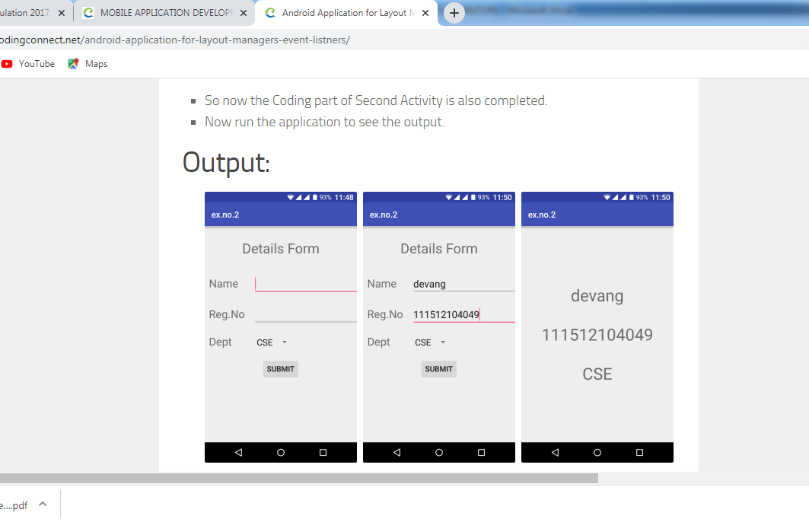

**RESULT**

Thus a Simple Android Application that uses Layout Managers and Event Listeners is developed and executed successfully.